UNCOVERING THE GAMING INDUSTRY’S HIDDEN GEMS: A COMPREHENSIVE ANALYSIS OF VIDEO GAME SALES

INTRODUCTION:-

OVERVIEW:-

Video game sales analysis is the process of collecting and analysing data about the sales of video games in order to understand market trends and consumer behaviour. This type of analysis can be useful for variety of purposes, including identifying the most popular games and genre, predicting future sales and developing marketing strategies. Video game sales analysis typically involves collecting data from Kaggle sources. It was generated by a scrape of vgcharts.com. This data may include information about the number of units sold, the retail price and the platforms which the games are played. This project is a complete analysis of video games sold since 1980. It consist of video games with their publishers and platforms with the genre of games on which year they were published with the sales they made in North America, Japan, Europe and other regions.

PURPOSE:-

Studies show that playing games in the classroom can increase overall motivation. Students become more motivated to learn, pay attention and participate in class activities. They can also be a great classroom management tool, helping to motivate a class. The benefits of video games include improved powers of concentration, creativity, memory, languages and teamwork.

PROBLEM DEFINITION AND DESIGN THINKING:-

EMPATHY MAP:-



IDEATION AND BRAINSTROMING:-

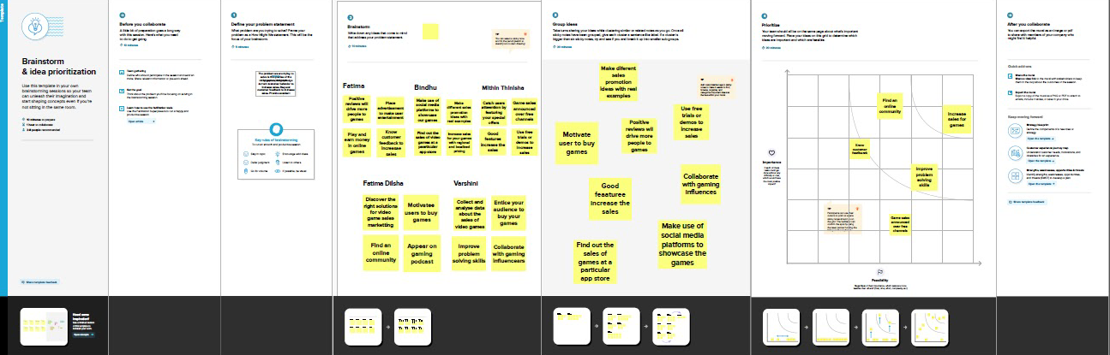

RESULT:-

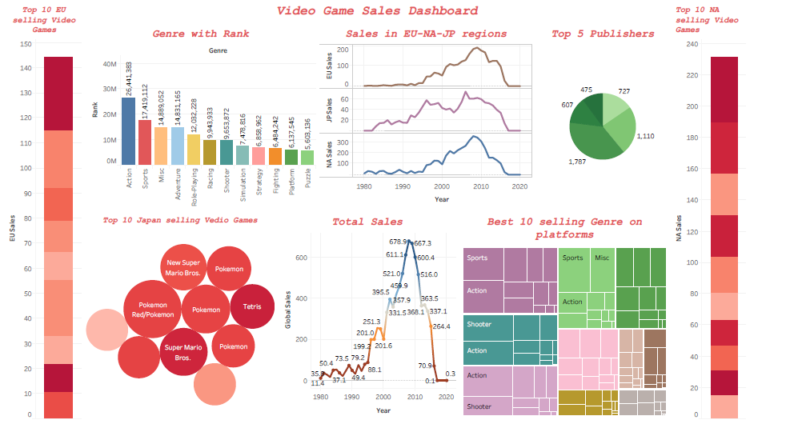

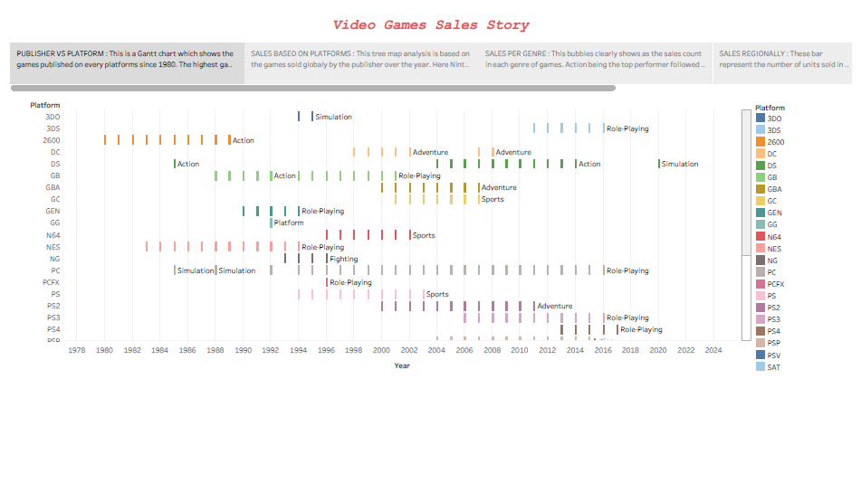

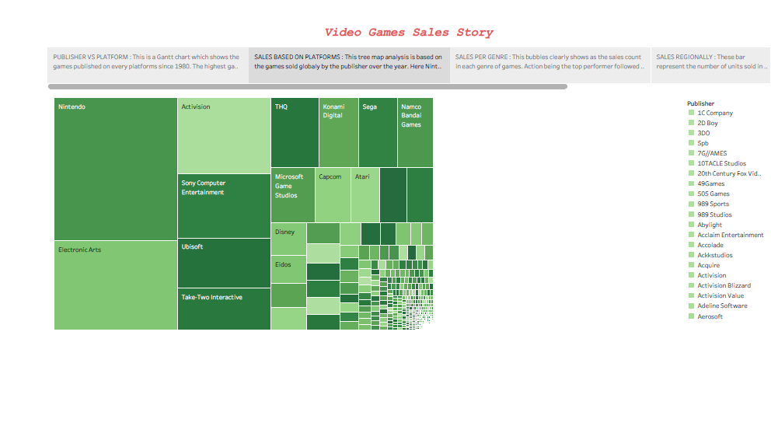

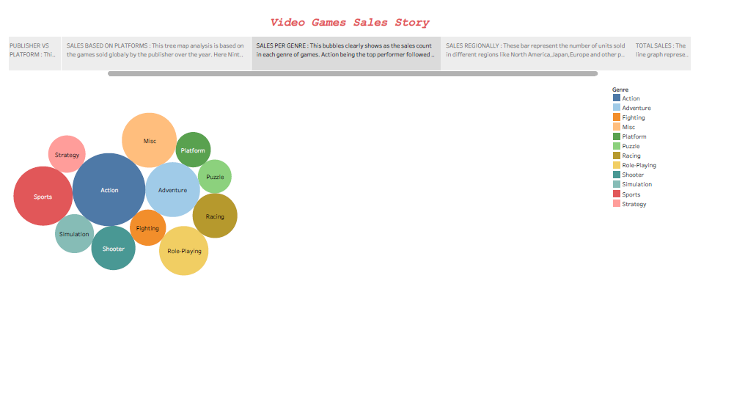

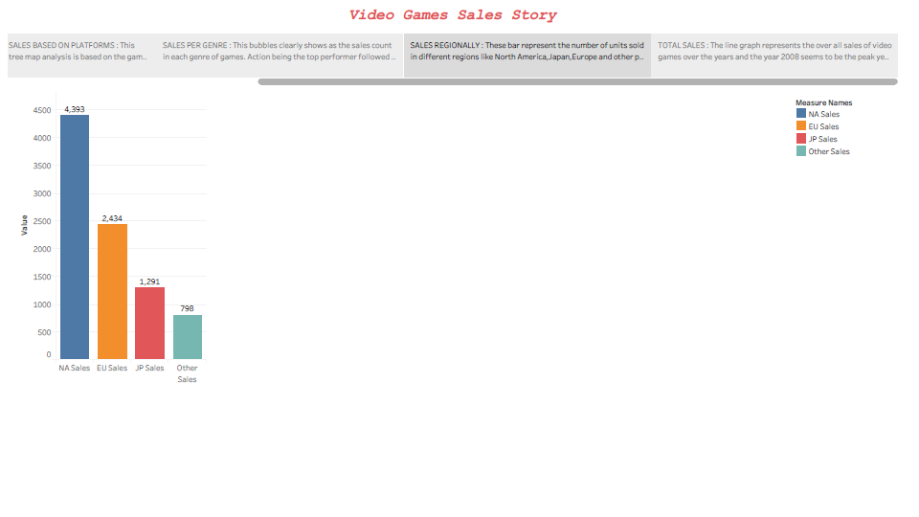

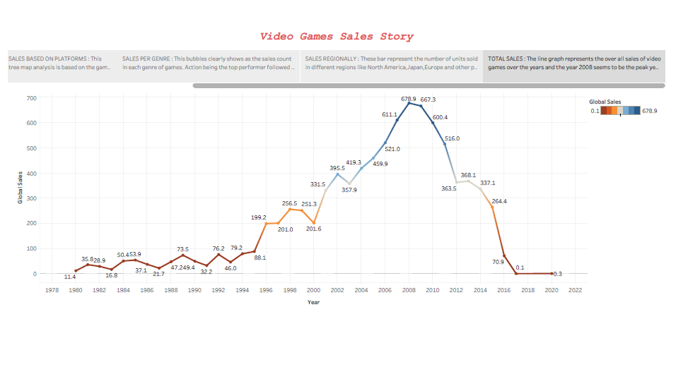

ADVANTAGES AND DISADVANTAGES:-

ADVANTAGES:-

* Video games have shown to improve cognitive abilities
* Visuospatial ability (the ability to recognize objects around you and estimate the distances between them)
* Increased processing speed
* Deductive reasoning
* Mathematical intelligence.
* Problem-solving skills and the use of logic
* Hand-to-eye coordination
* Faster and more accurate decision-making
* Improved eye for details
* Social activity and teamwork
* Improved performance in school more grey matter and better brain connectivity.

DISADVANTAGES:-

* Video games can make you addicted
* Elevated risk of aggression
* Games replace real-world problems
* Some games promote gambling
* Decreased physical and mental health
* Lack of focus and concentration
* Excessive playtime can lead to increased isolation and loneliness, which are linked to mental health problems like depression and social anxiety.

APPLICATIONS:-

Gaming industry finds a huge market in the smart phone based customers. There are mobile friendly games specially being developed by various developers as they are understand this idea of smart phone connectivity has the potential to provide with the best possibility of games .Internet based gaming and such devices has made the gaming industry become more versatile in terms of providing games of various kinds . There are video game versions of games like cricket, tennis , football, etc.... which can be played using wearables. Also there is a wide range of games like ludo, chess, pokemon go etc .... are all present in such a way that can be played by people calling their friends and family on board .The Casino industry also tends to use modern day gaming technologies to attract and retain new customers by connecting the games to various kinds of money adding and withdrawing platforms they also try to ensure a smooth and convenient user.

CONCLUSION:-

As you have probably noticed by now if you have gone through other parts of the site, there are many conflicting thoughts and even studies regarding this topics. This leads myself to believe that there are multiple factors that result in the effects these studies are showing us. Video games are a way to express one’s self. You control your character, you decide how they will act, you choose how they will respond. It is not a simple answer that all video games are bad or all video games are good. The effects of video games, positive or negative, depend on several factors, the most major one being you and how you play the game. Video games, by themselves, have little to no effect on you mentally, but what you do and how you react can.

FUTURE SCOPE:-

      The future of video games is bright, with billions of gamers worldwide and revenues in the hundreds of billions of dollars. The games and interactive medias market more then $120 billion in 2019, according to super data; mobile games generated more then half that PC and gaming consoles generated $29.6 billion and $15.4 billion, respectively. As the gaming industry evolves, companies such as Nintendo, Sony, and Microsoft continue to advance innovation in the game console space. Understanding the industry’s history can help offer a glimpse into the future of video games. The Oregon Trail (developed by the Minnesota Education Computing consortium), the Atari video computer system, and arcade game space Invaders (made by Taito).Three big trends are changing the video game industry: better technology, and new monetization models. Good franchise management and fan engagement also will become more critical the ever, prompting leading companies to put it at the centre of decisions. Success will require finding and keeping the best creative. The future of the video game industry looks dazzling. Consumer demand is growing, technology is advancing quickly, and new monetization models are taking off. Bain’s analysis forecast that global revenue for games could grow by more than 50% over the next five years. And gamers’ foothold in virtual worlds collectively called the meta verse is far ahead of other consumers. All this suggests that gaming will take consumers’ time from other forms of media and be the foundational platform for both other media and non media experiences, becoming an ever greater part of our daily lives.

APPENDIX:-

<!DOCTYPE html>

<html lang="en-US">

 <head>

 <meta charset="utf-8" />

 <meta name="viewport" content="width=device-width" />

 <title>My Test Page</title>

 </head>

<body>

 <h1>UNCOVERING THE GAMING INDUSTRY</h1>

<p>

 INTRODUCTION:-

OVERVIEW:-

 Video game sales analysis is the process of collecting and analysing data

about the video games in order to understand market trends and consumer behaviour.

This type of analysis can be useful for variety of purpose including identifying

the most popular games and genres, predicting future sale and developing marketing

strategies. Video games sales analysis typically involves collecting data from

Kaggle sources. It was generated by scrape of [vgcharts.com](http://vgcharts.com). This data may include

information about the number of units sold, the retail price and the platforms on

which the games are played. Once the data has been collected it is typically

analysed using tableau. It is an important part of the video game industries, as

it helps to understand the needs and preference of consumers and to identify

opportunities for growth and innovation.

PURPOSE:-

 Studies show that playing games in the classroom can increase overall

motivation. Students become more motivated to learn, pay attention and

participate in class activities. They can also be a great classroom management

tool helping to motivate the class The video game industry encompasses the

development, marketing and monetization of video games. The industry encompasses

dozens of job disciplines and thousands of jobs worldwide.

</p>

<h1>Dashboard</h1>

<div class='tableauPlaceholder' id='viz1681204204427' style='position:

relative'><noscript><a href='#'><img alt=' '

src='https:&#47;&#47;[public.tableau.com](http://public.tableau.com)&#47;static&#47;images&#47;Vi&#47;Videogames

ales_16804492604530&#47;Dashboard1&#47;1_rss.png' style='border: none'

/></a></noscript><object class='tableauViz' style='display:none;'><param

name='host_url' value='https%3A%2F%[2Fpublic.tableau.com](http://2Fpublic.tableau.com)%2F' /> <param

name='embed_code_version' value='3' /> <param name='site_root' value='' /><param

name='name' value='Videogamesales_16804492604530&#47;Dashboard1' /><param

name='tabs' value='yes' /><param name='toolbar' value='yes' /><param

name='static_image'

value='https:&#47;&#47;[public.tableau.com](http://public.tableau.com)&#47;static&#47;images&#47;Vi&#47;Videogam

esales_16804492604530&#47;Dashboard1&#47;1.png' /> <param name='animate_transition'

value='yes' /><param name='display_static_image' value='yes' /><param

name='display_spinner' value='yes' /><param name='display_overlay' value='yes'

/><param name='display_count' value='yes' /><param name='language' value='en-US'

/></object></div> <script type='text/javascript'>

var divElement = document.getElementById('viz1681204204427');

var vizElement = divElement.getElementsByTagName('object')[0];

if ( divElement.offsetWidth > 800 ) {

vizElement.style.minWidth='1400px';vizElement.style.maxWidth='100%';vizElement.styl

e.minHeight='850px';vizElement.style.maxHeight=(divElement.offsetWidth*0.75)+'px';}

else if ( divElement.offsetWidth > 500 ) {

vizElement.style.minWidth='1400px';vizElement.style.maxWidth='100%';vizElement.styl

e.minHeight='850px';vizElement.style.maxHeight=(divElement.offsetWidth*0.75)+'px';}

else {

vizElement.style.width='100%';vizElement.style.minHeight='2450px';vizElement.style.

maxHeight=(divElement.offsetWidth*1.77)+'px';} var

scriptElement = document.createElement('script');

scriptElement.src = '<https://public.tableau.com/javascripts/api/viz_v1.js>';

 vizElement.parentNode.insertBefore(scriptElement, vizElement);

 </script>

</p>

<h2>Story</h2>

<div class='tableauPlaceholder' id='viz1681204796994' style='position:

relative'><noscript><a href='#'><img alt=' '

src='https:&#47;&#47;[public.tableau.com](http://public.tableau.com)&#47;static&#47;images&#47;Vi&#47;Videogames

ales_16804492604530&#47;Story1&#47;1_rss.png' style='border: none'

/></a></noscript><object class='tableauViz' style='display:none;'><param

name='host_url' value='https%3A%2F%[2Fpublic.tableau.com](http://2Fpublic.tableau.com)%2F' /> <param

name='embed_code_version' value='3' /> <param name='site_root' value='' /><param

name='name' value='Videogamesales_16804492604530&#47;Story1' /><param name='tabs'

value='yes' /><param name='toolbar' value='yes' /><param name='static_image'

value='https:&#47;&#47;[public.tableau.com](http://public.tableau.com)&#47;static&#47;images&#47;Vi&#47;Videogam

esales_16804492604530&#47;Story1&#47;1.png' /> <param name='animate_transition'

value='yes' /><param name='display_static_image' value='yes' /><param

name='display_spinner' value='yes' /><param name='display_overlay' value='yes'

/><param name='display_count' value='yes' /><param name='language' value='en-US'

/></object></div> <script type='text/javascript'>

var divElement = document.getElementById('viz1681204796994');

var vizElement = divElement.getElementsByTagName('object')[0];

vizElement.style.width='100%';vizElement.style.height=(divElement.offsetWidth*0.75)

+'px'; var scriptElement = document.createElement('script');

 scriptElement.src =

'<https://public.tableau.com/javascripts/api/viz_v1.js>';

vizElement.parentNode.insertBefore(scriptElement, vizElement);

</script>

<h2>Conclusion</h2>

</body>

</html>